# Transistors Table of Contents

**Transistors Table of Contents 1**

**What is a Transistor? 2**

**Bipolar Junction Transistors (BJT) 3**

**Bipolar Junction Transistors (BJT) (cont.) 4**

**Field-Effect Transistors (FET) 5**

**Field-Effect Transistors (FET) (cont.) 6**

**References 7**

# 

# 

# What is a Transistor?

Introduction:

A transistor is a semiconductor device that can be used as an amplifier, a switch, or for signal modulation. It is a fundamental building block in modern electronic circuits and is used extensively in various electronic devices, including computers, radios, televisions, and many other electronic systems.

There are two main types of transistors: **bipolar junction transistors (BJTs) and field-effect transistors (FETs)** Each type has its own subcategories and variations, but they all serve the same basic purpose of controlling the flow of electrical current.

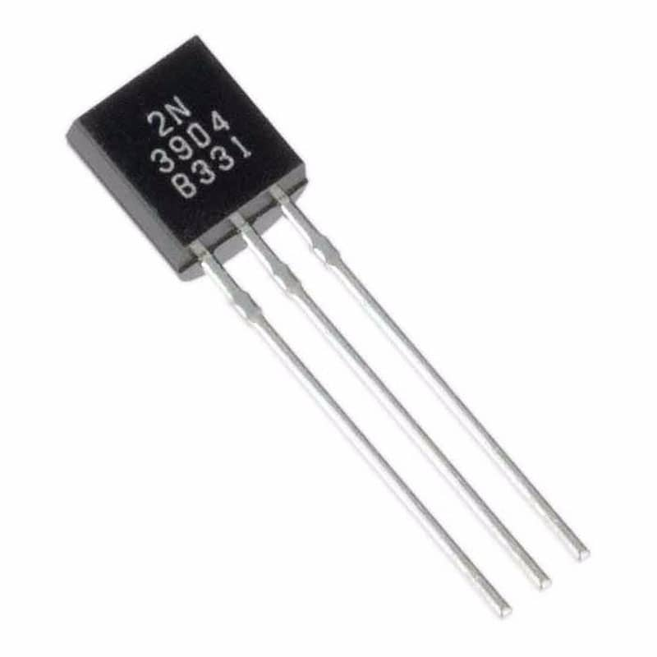

Bipolar Junction Transistor [5]

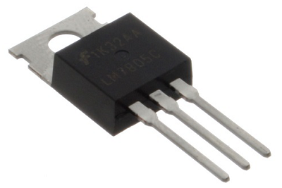

MOSFET Transistor [6]

# Bipolar Junction Transistors (BJT)

Composition:

* BJTs are composed of three semiconductor layers: the emitter, the base, and the collector.
* Two types of BJTs: **NPN (negative-positive-negative) and PNP (positive-negative-positive)**.
* These accomplish the same tasks but in different ways due to the difference in semi-conductor material arrangement [4].
* Control the flow of current by using the movement of charge carriers, (a small current).

Operation:

* In a NPN transistor, when no current flows into the base, current is unable to flow from the collector to the emitter.
* However, when even a little current flows into the base, the larger load current is able to flow from the collector to the emitter, thus turning the transistor on.
* **The current flowing between the collector and emitter terminals is controlled by the current flowing into the base terminal.**

Applications:

* For use with low power electronics.
* Generally have two broad applications, to modulate/amplify a signal or to function as a electronic switch.

*Signal Modulation*

* Can take a small input signal and produce a larger output signal, providing signal gain.
* Modulation involves varying certain parameters of a carrier signal to encode information.
* There are two kinds of modulation, **FM and AM modulation**, in both, BJTs control either the frequency or the amplitude respectively
* BJTs can also be used in the demodulation process to extract the original information signal from the modulated carrier signal

# Bipolar Junction Transistors (BJT) (cont.)

*Switches*

* BJTs can operate as electronic switches in digital circuits.
* By controlling the base current, the transistor can be turned on or off, allowing or blocking the flow of current between the collector and emitter.
* Because they can be either on, (1), or off, (2), **they can be used in digital logic gates, (that use TTL or Transistor-Transistor Logic when using BJTs**).
* [Here is an example](https://www.tinkercad.com/things/2RnNubQNP79-inverter-using-npn-transistor) of a NPN transistor being used in an inverter.
* These logic gates are the building blocks for every microcontroller and processor which emply millions of these to perform logic operations and control tasks.

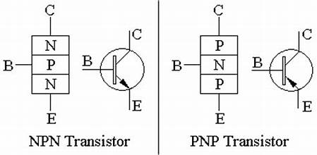

NPN and PNP Transistors [4]

# Field-Effect Transistors (FET)

Composition:

* FETs, on the other hand, have three terminals: the source, the gate, and the drain. The flow of current between the source and drain terminals is controlled by the voltage applied to the gate terminal.
* There are two main types of FETs: the **metal-oxide-semiconductor FET (MOSFET)** and the junction FET (JFET). MOSFETS are generally the most common ones you will see of this type.
* The main difference between FETs and BJTs are that FETs use and electric field to control the flow of current.

Operation:

*Disclaimer: This is specifically describing a MOSFET as they are much more common*

* In the case of a N channel MOSFET, the gate is separated from the P type material by the metal-oxide insulator.
* This creates a capacitor where the insulator is the dielectric.
* **When this capacitor is charged, the electric field causes current to flow across the transistor from drain to source.**
* **The capacitor becomes charged when there is voltage applied to the gate, (this functions similar to how the base pin does in a BJT).**

Applications:

* Generally for use with higher power electronics as they have a metal that can connect with a heat sink to help remove the heat that is generated.
* Low power consumption, (**current is only consumed when changing between states, this is especially important when it comes to logic gates**).
* Much more electrostatically sensitive due to their extremely thin dielectric layer.
* MOSFETs use a type of logic called **CMOS, (Complementary Metal-Oxide-Semiconductor**), as they are commonly used in logic gates.
* However this is irrelevant for JFETs as they are rarely used for logic gates.

# Field-Effect Transistors (FET) (cont.)

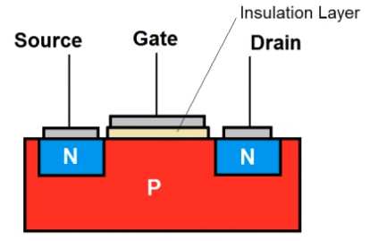

N channel MOSFET (N and P are flipped in P channel MOSFET) [7]

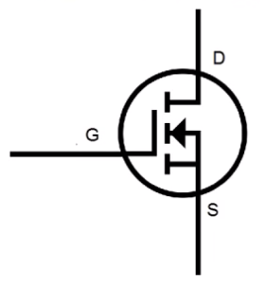

N channel MOSFET schematic view [8]

# 

# References

# 

[1] “Transistors Explained - How transistors work,” *www.youtube.com*. https://youtu.be/J4oO7PT_nzQ?si=iRw046NkNBbQJ3H- (accessed Dec. 17, 2023).

[2] “Transistors - NPN & PNP - Basic Introduction,” *www.youtube.com*. https://youtu.be/AcxDiesy-nI?si=wQm93MJm3g9C5ewE (accessed Dec. 17, 2023).

[3] E. Arslan, “AkademikPort - Elektronik Devre Elemanları - Transistör,” *Elektrikport.com*, 2015. https://akademi.elektrikport.com/Ders/81/540/Elektronik-Devre-Elemanlari/Transistor/Yapisi (accessed Dec. 17, 2023).

[4] “Reed Switch Motor With Transistor,” *Simple Electric Motors*, Apr. 11, 2014. https://simplemotor.com/transistor-motor/ (accessed Dec. 17, 2023).

[5] “2N3904 Transistor BJT NPN 40V TO-92,” *UNIT Electronics*. https://uelectronics.com/producto/2n3904-transistor-bjt-npn-40v-to-92/

[6] “Eletrônica Básica - MOSFET,” *Stack*. https://isolution.pro/pt/t/basic-electronics/basic-electronics-mosfet/eletronica-basica-mosfet (accessed Dec. 17, 2023).

[7]“Transistor MOSFET Canal N Canal P JFET Hetpro TUTORIALES,” HETPRO/TUTORIALES, Nov. 18, 2017. https://hetpro-store.com/TUTORIALES/transistor-mosfet/

[8]“8-Bit Adder built from 152 Transistors,” www.youtube.com. https://youtu.be/X31B1pVow1o?si=YHaYDjeQ7G0Dw6J9 (accessed Dec. 19, 2023).

‌

‌

# 